00

**FINAL ASSESSMENT**

**PRACTICAL TEST**

SESSION II: 2023/2024

**DFP50293 MOBILE APPLICATION DEVELOPMENT**

NAME : ANDRIAN SELIANG JETTLE

REGISTRATION NO. : 05DDT21F1049

SECTION : S1

JABATAN TEKNOLOGI MAKLUMAT DAN KOMUNIKASI



**MainActivity.java**

package com.example.myprofile_05ddt21f1049;  
  
import android.content.Intent;  
import android.os.Bundle;  
import androidx.appcompat.app.AppCompatActivity;  
  
public class MainActivity extends AppCompatActivity {  
 @Override  
 protected void onCreate(Bundle savedInstanceState) {  
 super.onCreate(savedInstanceState);  
 Intent intent = new Intent(MainActivity.this, LoginActivity.class);  
 startActivity(intent);  
 finish();  
 }  
}

**AndroidManifest.xml**

<manifest xmlns:android="http://schemas.android.com/apk/res/android"  
 package="com.example.myprofile_05ddt21f1049">  
  
 <application  
 android:allowBackup="true"  
 android:icon="@mipmap/ic_launcher"  
 android:label="MyProfile"  
 android:roundIcon="@mipmap/ic_launcher_round"  
 android:supportsRtl="true">  
  
 <activity android:name=".MainActivity"  
 android:theme="@style/Theme.AppCompat.DayNight.DarkActionBar"  
 android:exported="true">  
 <intent-filter>  
 <action android:name="android.intent.action.MAIN" />  
 <category android:name="android.intent.category.LAUNCHER" />  
 </intent-filter>  
 </activity>  
  
 <activity android:name=".LoginActivity"  
 android:theme="@style/Theme.AppCompat.DayNight.DarkActionBar"  
 android:exported="true" />  
  
 <activity android:name=".ProfileActivity"  
 android:theme="@style/Theme.AppCompat.DayNight.DarkActionBar"  
 android:exported="true" />  
  
 </application>  
</manifest>

**LoginActivity.java**

package com.example.myprofile_05ddt21f1049;  
  
import android.content.Intent;  
import android.os.Bundle;  
import android.view.View;  
import android.widget.Button;  
import android.widget.EditText;  
import android.widget.Toast;  
import androidx.appcompat.app.AppCompatActivity;  
  
public class LoginActivity extends AppCompatActivity {  
  
 private EditText etName;  
 private EditText etNric;  
 private Button btnLogin;  
  
 @Override  
 protected void onCreate(Bundle savedInstanceState) {  
 super.onCreate(savedInstanceState);  
 setContentView(R.layout.*activity_login*);  
  
 etName = findViewById(R.id.*etName*);  
 etNric = findViewById(R.id.*etNric*);  
 btnLogin = findViewById(R.id.*btnLogin*);  
  
 btnLogin.setOnClickListener(new View.OnClickListener() {  
 @Override  
 public void onClick(View v) {  
 String name = etName.getText().toString();  
 String nric = etNric.getText().toString();  
  
 if (name.equals("Andrian") && nric.equals("123456789")) {  
 Intent intent = new Intent(LoginActivity.this, ProfileActivity.class);  
 intent.putExtra("name", name);  
 startActivity(intent);  
 } else {  
 Toast.*makeText*(LoginActivity.this, "Invalid login", Toast.*LENGTH_SHORT*).show();  
 }  
 }  
 });  
 }  
}

**activity_login**

<RelativeLayout xmlns:android="http://schemas.android.com/apk/res/android"  
 android:layout_width="match_parent"  
 android:layout_height="match_parent"  
 android:padding="16dp">  
  
 <TextView  
 android:id="@+id/tvNameLabel"  
 android:layout_width="wrap_content"  
 android:layout_height="wrap_content"  
 android:text="Name:" />  
  
 <EditText  
 android:id="@+id/etName"  
 android:layout_width="match_parent"  
 android:layout_height="wrap_content"  
 android:layout_below="@id/tvNameLabel"  
 android:layout_marginTop="8dp" />  
  
 <TextView  
 android:id="@+id/tvNricLabel"  
 android:layout_width="wrap_content"  
 android:layout_height="wrap_content"  
 android:layout_below="@id/etName"  
 android:layout_marginTop="16dp"  
 android:text="NRIC:" />  
  
 <EditText  
 android:id="@+id/etNric"  
 android:layout_width="match_parent"  
 android:layout_height="wrap_content"  
 android:layout_below="@id/tvNricLabel"  
 android:layout_marginTop="8dp" />  
  
 <Button  
 android:id="@+id/btnLogin"  
 android:layout_width="wrap_content"  
 android:layout_height="wrap_content"  
 android:layout_below="@id/etNric"  
 android:layout_marginTop="16dp"  
 android:text="Login" />  
</RelativeLayout>

**ProfileActivity.java**

package com.example.myprofile_05ddt21f1049;  
  
import android.os.Bundle;  
import android.view.View;  
import android.widget.Button;  
import android.widget.ImageView;  
import android.widget.TextView;  
import android.widget.Toast;  
import androidx.appcompat.app.AppCompatActivity;  
  
public class ProfileActivity extends AppCompatActivity {  
  
 private TextView tvName;  
 private ImageView ivProfilePicture;  
 private Button btnUpdateProfile;  
  
 @Override  
 protected void onCreate(Bundle savedInstanceState) {  
 super.onCreate(savedInstanceState);  
 setContentView(R.layout.*activity_profile*);  
  
 tvName = findViewById(R.id.*tvName*);  
 ivProfilePicture = findViewById(R.id.*ivProfilePicture*);  
 btnUpdateProfile = findViewById(R.id.*btnUpdateProfile*);  
  
 String name = getIntent().getStringExtra("name");  
 tvName.setText(name);  
  
 btnUpdateProfile.setOnClickListener(new View.OnClickListener() {  
 @Override  
 public void onClick(View view) {  
 Toast.*makeText*(ProfileActivity.this, "Your profile has successfully updated", Toast.*LENGTH_SHORT*).show();  
 }  
 });  
 }  
}

**activity_profile.xml**

<LinearLayout xmlns:android="http://schemas.android.com/apk/res/android"  
 android:layout_width="match_parent"  
 android:layout_height="match_parent"  
 android:orientation="vertical"  
 android:padding="16dp">  
  
 <TextView  
 android:id="@+id/tvName"  
 android:layout_width="wrap_content"  
 android:layout_height="wrap_content"  
 android:text="Name:"  
 android:textSize="18sp" />  
  
 <ImageView  
 android:id="@+id/ivProfilePicture"  
 android:layout_width="wrap_content"  
 android:layout_height="wrap_content"  
 android:src="@drawable/profilepic"  
 android:layout_marginTop="16dp" />  
  
 <Button  
 android:id="@+id/btnUpdateProfile"  
 android:layout_width="wrap_content"  
 android:layout_height="wrap_content"  
 android:layout_marginTop="16dp"  
 android:text="Update Profile" />  
</LinearLayout>

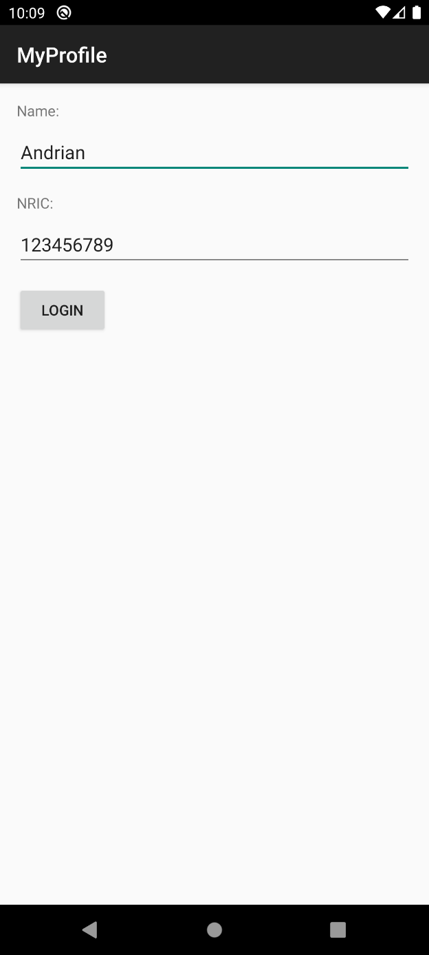**Output:**

